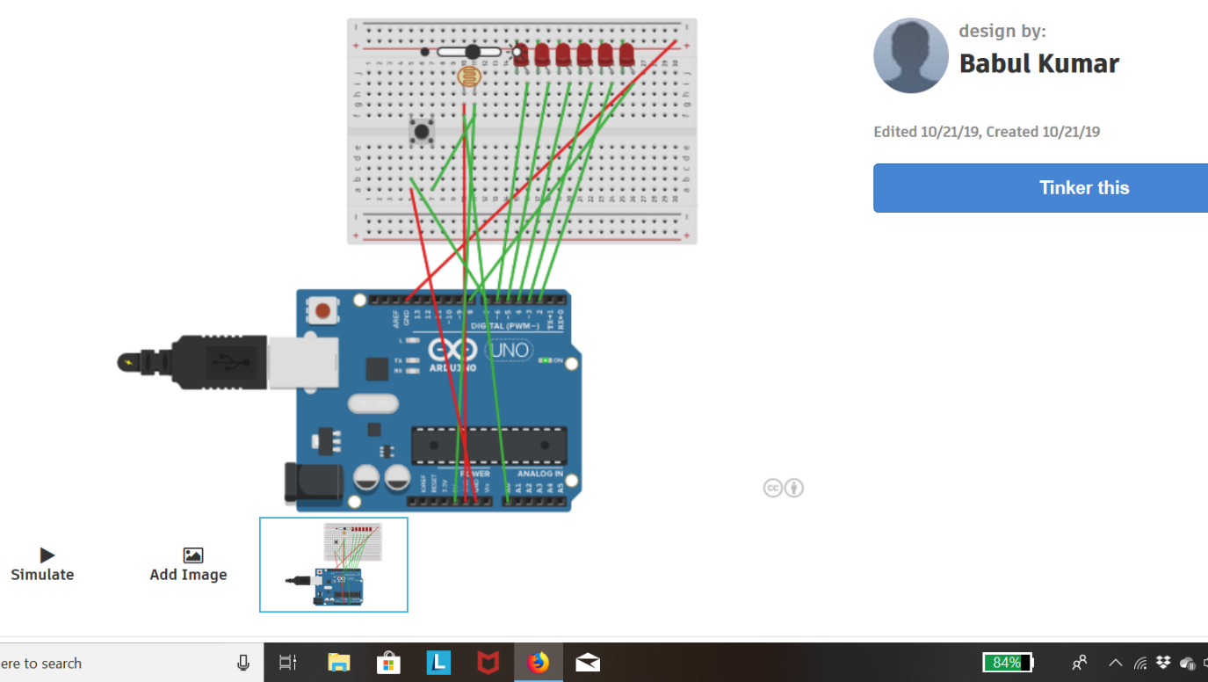

**CONCEPT USED:** *In this experiment ,we have use the concept of* ***LDR, PUSH BUTTON, BREADBOARD, ARDUNIO,LED*** *to make the circuit.And the basic*

*Of coding to run the program.*

***LEARNING & OBSERVATION:*** *we have learn how to make connec-*

*Tion by using the above circuit element and knows how to execute and run the*

*Program on the given task that has been given to me.*

***PROBLEM & TROUBLESHOOTING:****during performing the task I have got the problem in writing the code in precise manner and in assembling it I found some trouble but finally I achieved it.*

***PRECAUTIONS:****during performing the task you have to kept in mind that*

*If your code is correct but not running your circuit then you should atleast check*

*Is LED is fuse or not ,ardunio port working and handle the circuit element properly.*

***LEARNING OUTCOMES:****we come to know about the LDR,PUSHING BUTTON and their uses in several field of our life.we also knows their working principal in well mannered.*